**1. List and explain different PowerBi products?**

**Ans:**

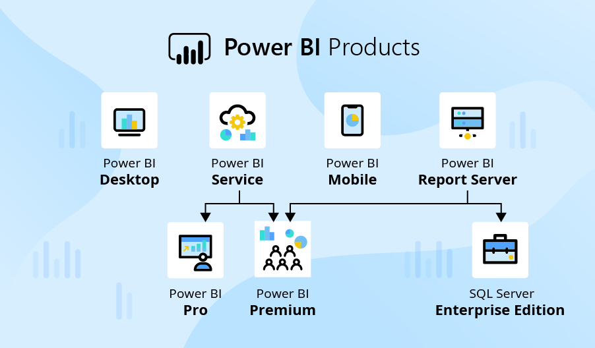

* **Power BI Desktop** : Power BI Desktop is a free desktop application you can install right on your own computer. Power BI Desktop works cohesively with the Power BI service by providing advanced data exploration, shaping, modeling, and report creation with highly interactive visualizations. You can save your work to a file, and publish your data and reports right to your Power BI site to share with others.
* **Power BI Service** : Power BI Pro isn’t hugely different to Power BI Desktop. They have the same visualization options, the same limits on storage and file upload size, and the same report refresh allowance. The key difference is that with Pro, you can share your data, reports, and dashboards with others privately—provided they also have a Power BI Pro license.
* **Power BI Premium**: Power BI Premium is an alternative way to get access to Power BI. Rather than purchasing licenses for individual users like you would with Power BI Pro, with Premium, you pay for the amount of space and processing capacity you want to carve out for your business. There are six capacity models, each one with varying amounts of memory so users can choose the amount they need to run their Power BI platform.
* **Power BI Report Server**: Power BI Report Server is an on-premises server product that ships with Power BI Premium. Report Server allows users to take advantage of Power BI on-premise. For some businesses, uploading their data to the cloud isn’t an option. This could be because there are data regulation laws applying to their particular industry, or maybe they don’t have the necessary infrastructure or connectivity where they are to be able to reliably access SaaS platforms.
* **Power BI Embedded**: Power BI Embedded allows Independent Software Vendors (ISVs) and developers to embed the functionality and capabilities of Power BI into their own apps on a pay-as-you-go, “white-label” basis. So, rather than building their own reporting features, they can simply add Power BI into their products, and Power BI will take care of all the reporting and data analysis needed. End users of the app won’t even know that the app’s analytics are powered by Power BI; it will just look like part of the app.
* **Power BI Mobile**: Power BI Mobile is (unsurprisingly) Power BI’s native mobile app and is available for Windows, iOS, and Android devices.

**2. What limitations of Excel, Microsoft solved by PowerBi?**

**Ans:**

* Excel has limitations in the amount of data it can work with. In contrast, Power BI can handle much larger amounts of data. Also, Unlike Excel, Power BI can be easily used from mobile devices.
* Power BI is a faster processing than Excel. Also Power BI dashboards are more visually appealing, interactive and customizable than those in Excel.
* Power BI is more users friendly and easy to use than excel.
* Excel doesn’t have advanced cross-filtering between graphics; on the other hand, Power BI supports cross-filtering filters between charts.
* In Excel, data is not automatically update but in Power BI, data is automatically updated.
* Difficult to connect separate table in Excel, but it is easy process to connect separate tables in Power BI with the help of data modelling.
* Excel is used to organize data, transform it and perform mathematical operations and calculations. On the other hand, Power BI is conceived as a business intelligence and data visualization tool for business.

**3. Explain PowerQuery?**

**Ans:**

Power Query is Microsoft’s Data Connectivity and Data Preparation technology. It basically, enables business users to access data stored in data sources seamlessly whilst, reshaping it to fit their needs. It’s easy to use, engaging, even convenient to use for the no-code users.

Power BI Desktop comes equipped with Power Query Editor. You can use the Power Query Editor to connect to one or many data sources, shape and transform the data. You could modify the data in hand to meet your needs, make it more usable, and then load that model into Power BI Desktop.

To get to the Query Editor, select Edit Queries from the Home tab of Power BI Desktop. With no data connections, the Query Editor appears quite dull, a blank pane as it should.

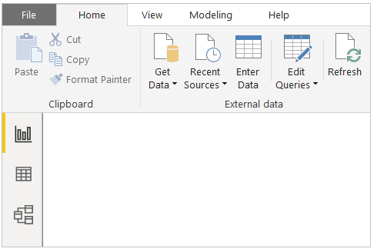

But once a query is loaded, this Editor view becomes way more interesting. If we connect to a data source, the Query Editor loads information about the data, which you can then begin to shape before basing your model on it.

**4. Explain PowerMap?**

**Ans:**

Power Map is similar in functionality. It provides you with a visual representation of an organization you are trying to infiltrate – what is the best way to get from Point A (virtually unknown) to Point B (well known throughout the Agency). As any experienced Capture Executive knows, there is a technique to applying a Power Map successfully. The path is planned, calculated, and adjusted along the way as new information comes to light. This sounds far more covert than intended.

A Power Map is a concept of where your company’s connections and areas of support lie within a specific organization, and where you have gaps in connections or contacts that need work.

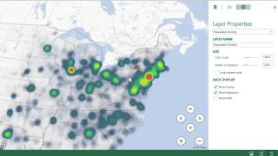

The Power Map isn’t just for you as a Capture Executive. It’s for everyone in the company to utilize and update. Bill in the cubicle next to yours may play golf on Saturday’s with someone in a power position, or perhaps he worked with him at a previous company. Your boss may have a very good relationship with the 1-Star Deputy Director of that organization. Visually depicting the Agency, the relationships, and the impact of specific individuals, as it pertains to your business pursuit, can help you strategize on where best to expend your capture resources. There are only so many hours in the day, and so many people in your organization – plan your Capture Management strategy wisely.

**5. How powerBi eliminated the need to host SharePoint Server on premises?**

**Ans:**

* Share point is an important part of how many organizations organize and distribute BI content to users. Over the last year, they have introduced Power BI web part for share point online and an updated reporting service report viewer web part for share point on-premises.
* Customers like the flexibility this gives them to build highly-customized share point experiences using their BI content.

**6. Explain the updates done in Power Bi Service(power BI 2.0) as compared to older version ?**

**Ans:**

Last updated done on September 2022. This release introduces Power BI report server for SQL server 2022. They continue to innovate, create and design to give everyone the ability to achieve more. In this new release of Power BI report server, they have done a lot of work to make sure they are empowering everyone. The release includes,

* Enhanced Windows Narrator support for the new windows Operating System and windows server.
* Security Enhancements.
* Browser performance improvements with angular.
* Accessibility BUG fixes.
* Support for SQL server 2022, preview instances report server catalog and feature updates.
* Improved the Power BI report server portal to provide more inclusive modern graphical interface
* Introduced the new paginated report migration tool, which connects to the web from the Power BI report server.